Using Text Colors in your programs

# Windows Machine (in DevC++, CodeBlocks IDEs etc.)

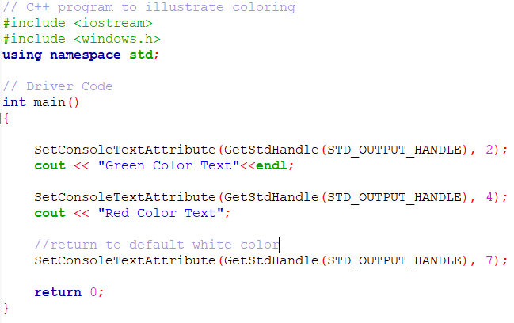

More info: <http://www.cplusplus.com/forum/beginner/54360/>

# Linux Machine (For command line (Ubuntu) programs)

//This will change colour to BOLD/BRIGHT and RED  
cout << "\033[1;31m";  
  
Its explanation is as follows:  
  
\033 -> escape character which tells the cout to wait for a command  
[ -> tells cout to follow the colour scheme provided next  
1 -> BOLD and BRIGHT (see table below for other options)  
; -> separator for next code  
31 -> code to change color to RED (see table below for other color codes)  
m-> instruction to change color ends here  
  
It is always advised to reset the changes back to default when you are done. This will be done by the following cout statement.   
  
//This is reset everything to as it was before/default  
cout <<"\033[0m";

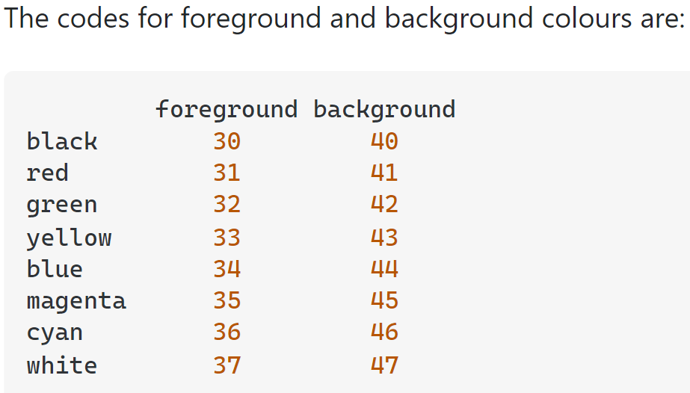

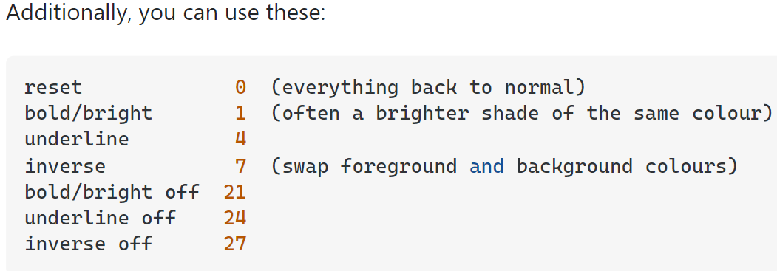

More escape codes: <https://en.wikipedia.org/wiki/ANSI_escape_code#Colors>   
Source: <https://stackoverflow.com/questions/2616906/how-do-i-output-coloured-text-to-a-linux-terminal>